CSCN 111 Assignment 2 “Car Range”

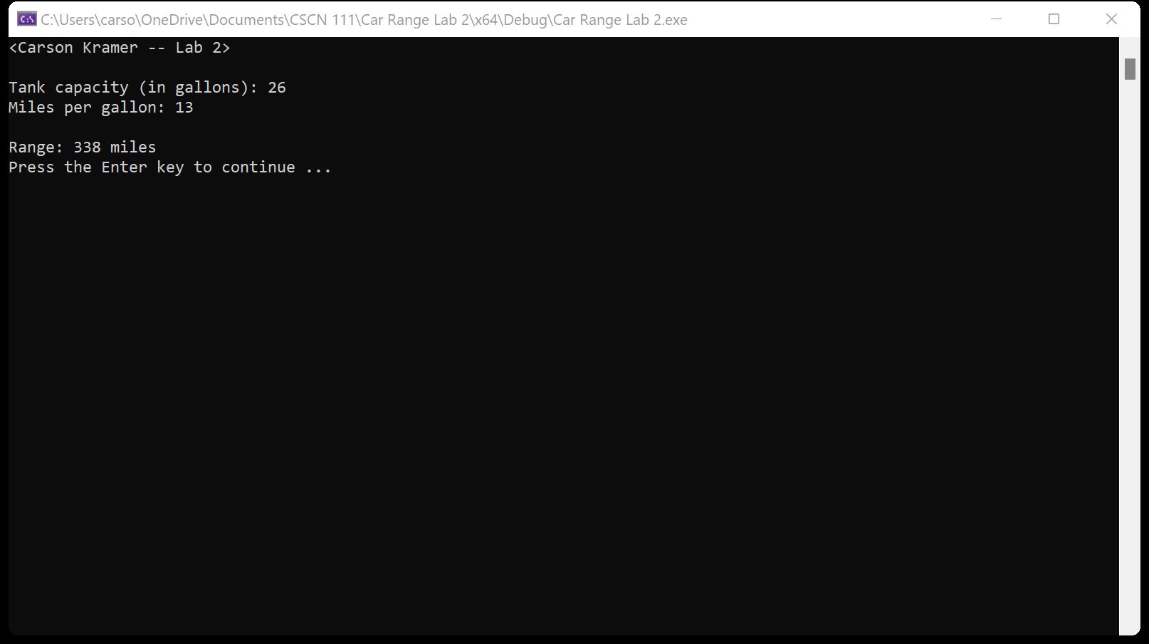

1. I have not shared the source code in my program with anyone other than my instructor’s approved human sources.
2. I have not used source code obtained from another student, or any other unauthorized source, either modified or unmodified.
3. If any source code or documentation used in my program was obtained from another source, such as a text book or course notes, that has been clearly noted with a proper citation in t he comments of my program.
4. I have not knowingly designed this program in such a way as to defeat or interfere with the normal operation of any machine it is graded on or to produce apparently correct results when in fact it does not.